**MODULES IN PYTHON**

1. Import Specific Attributes from a Python module

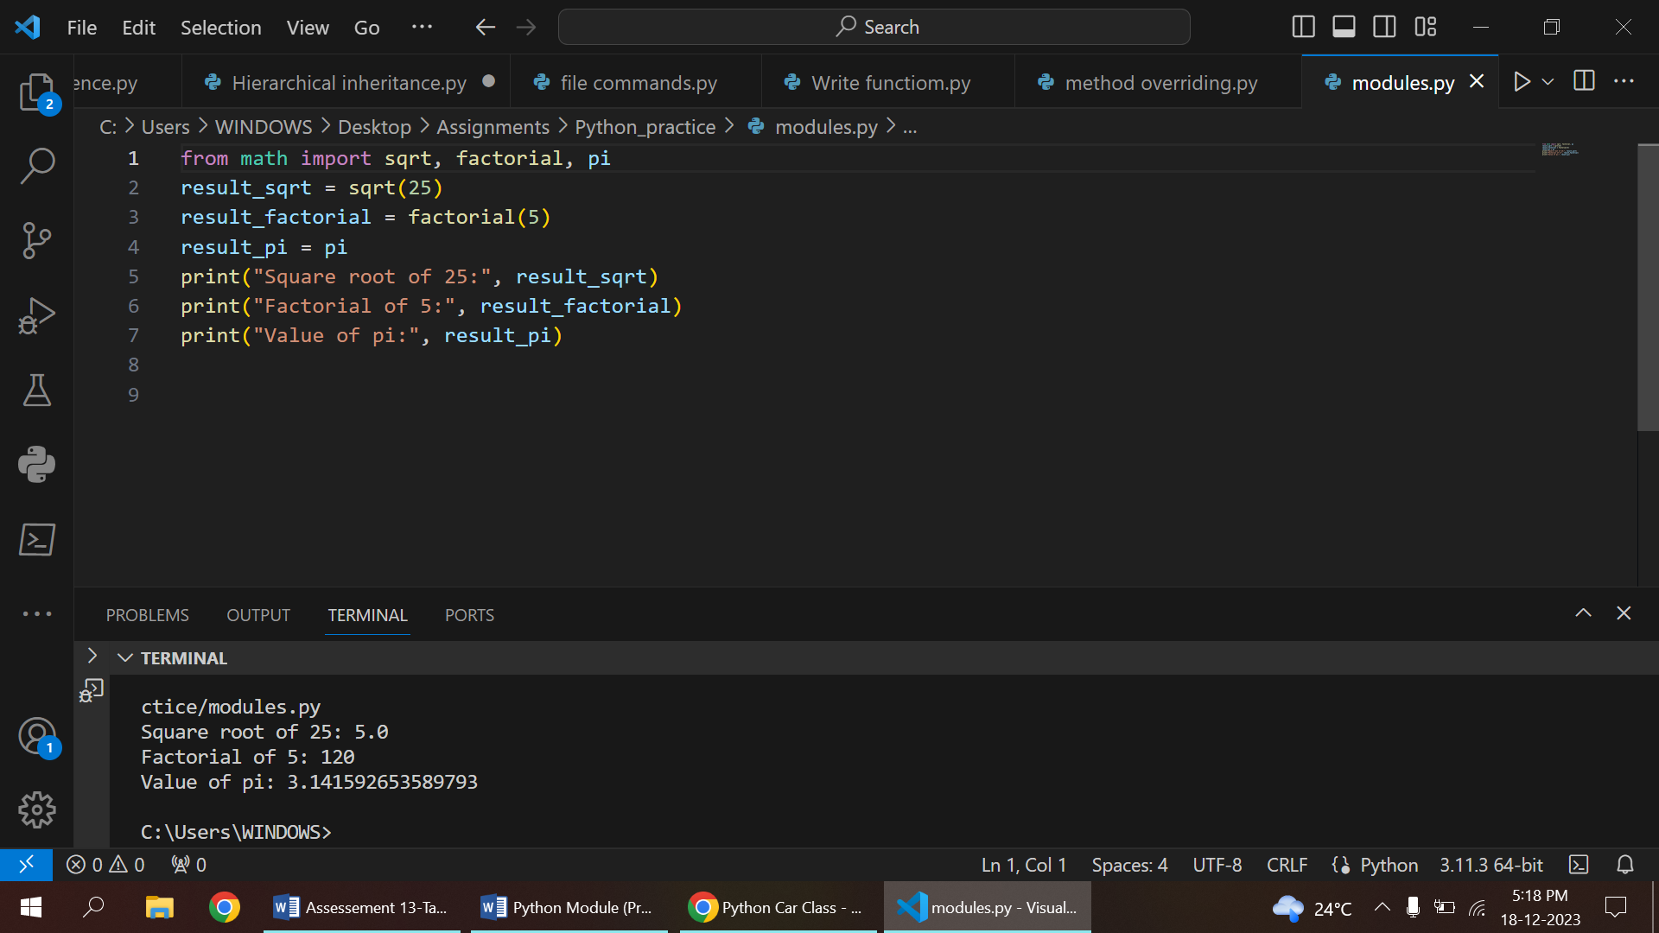

2. Import all Names

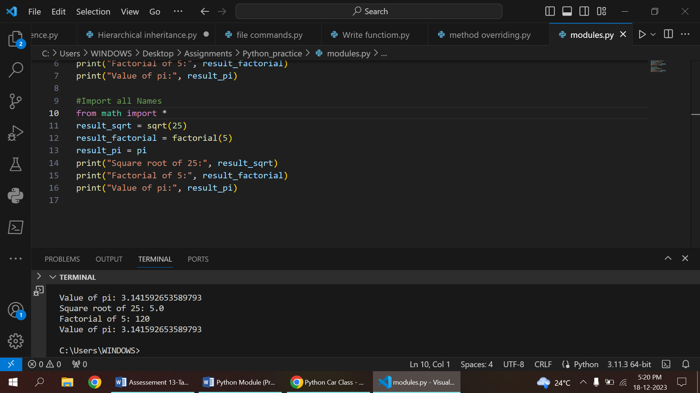

3. Locating Python Modules

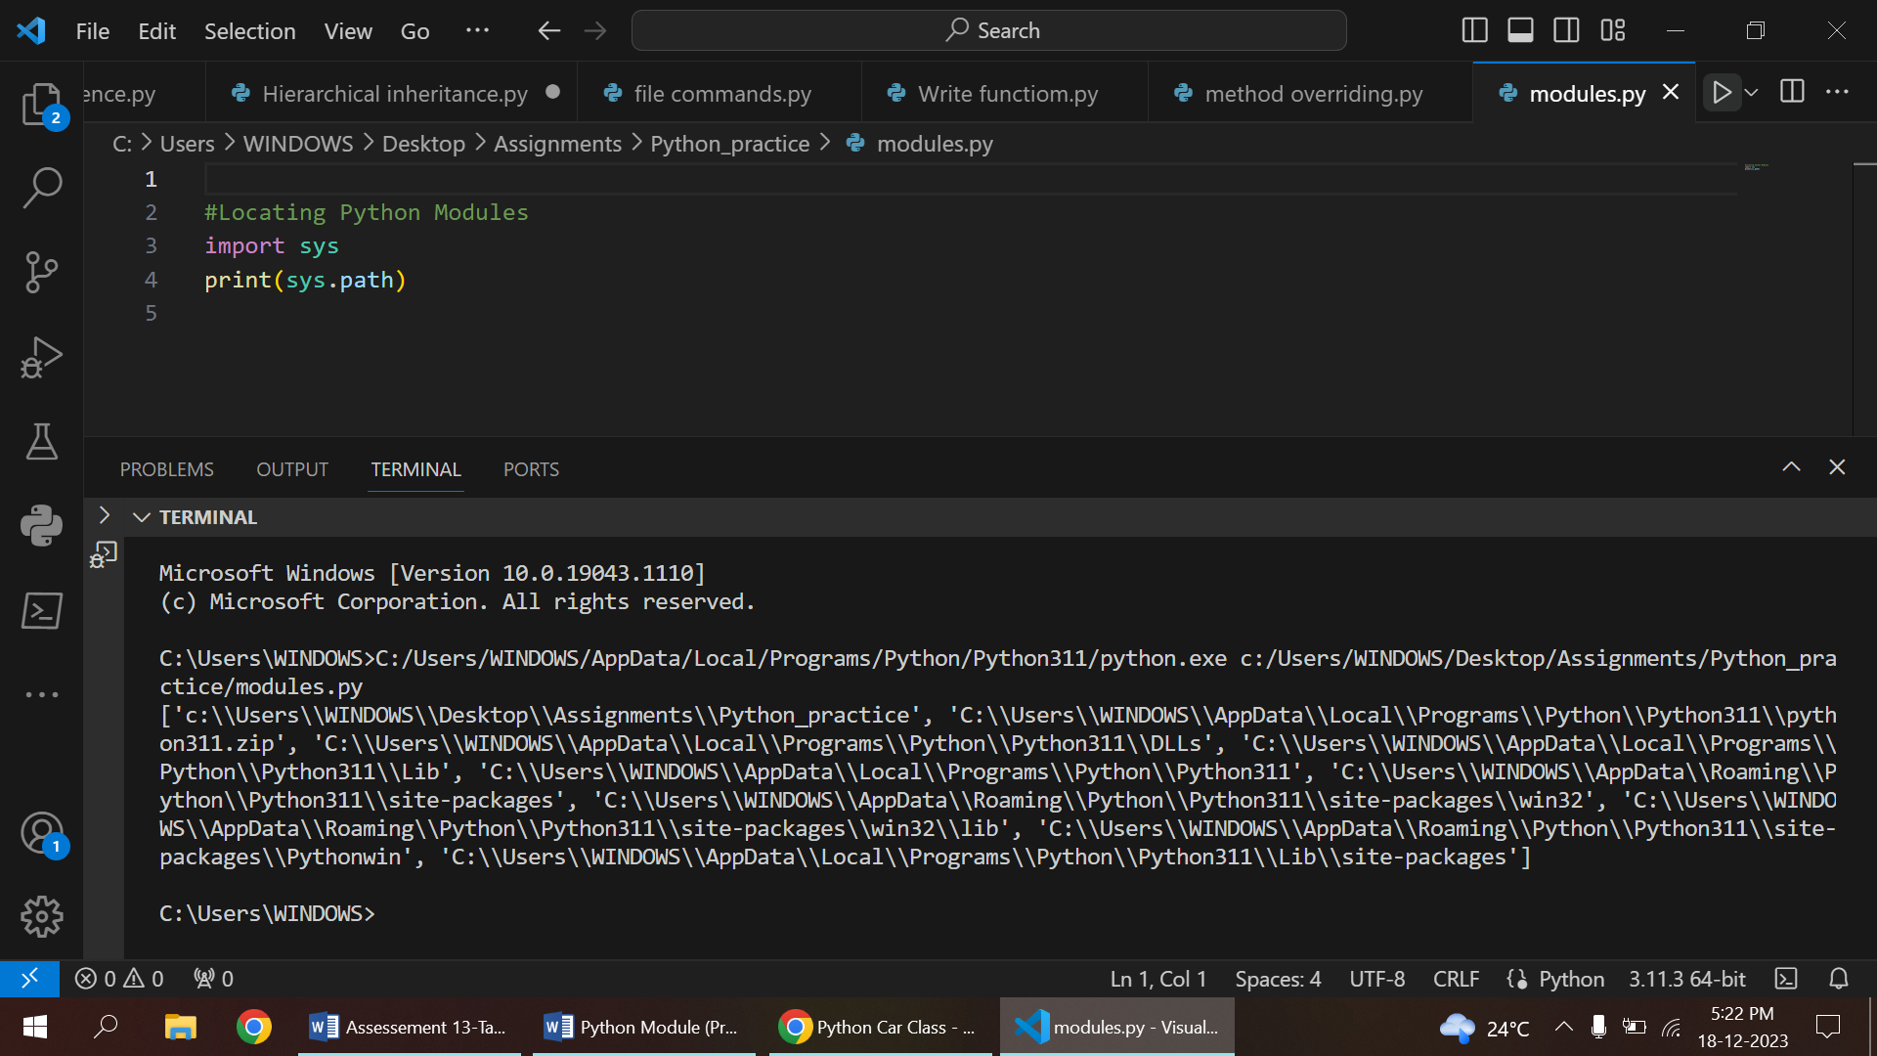

**CSV FILES**

1.Read CSV File

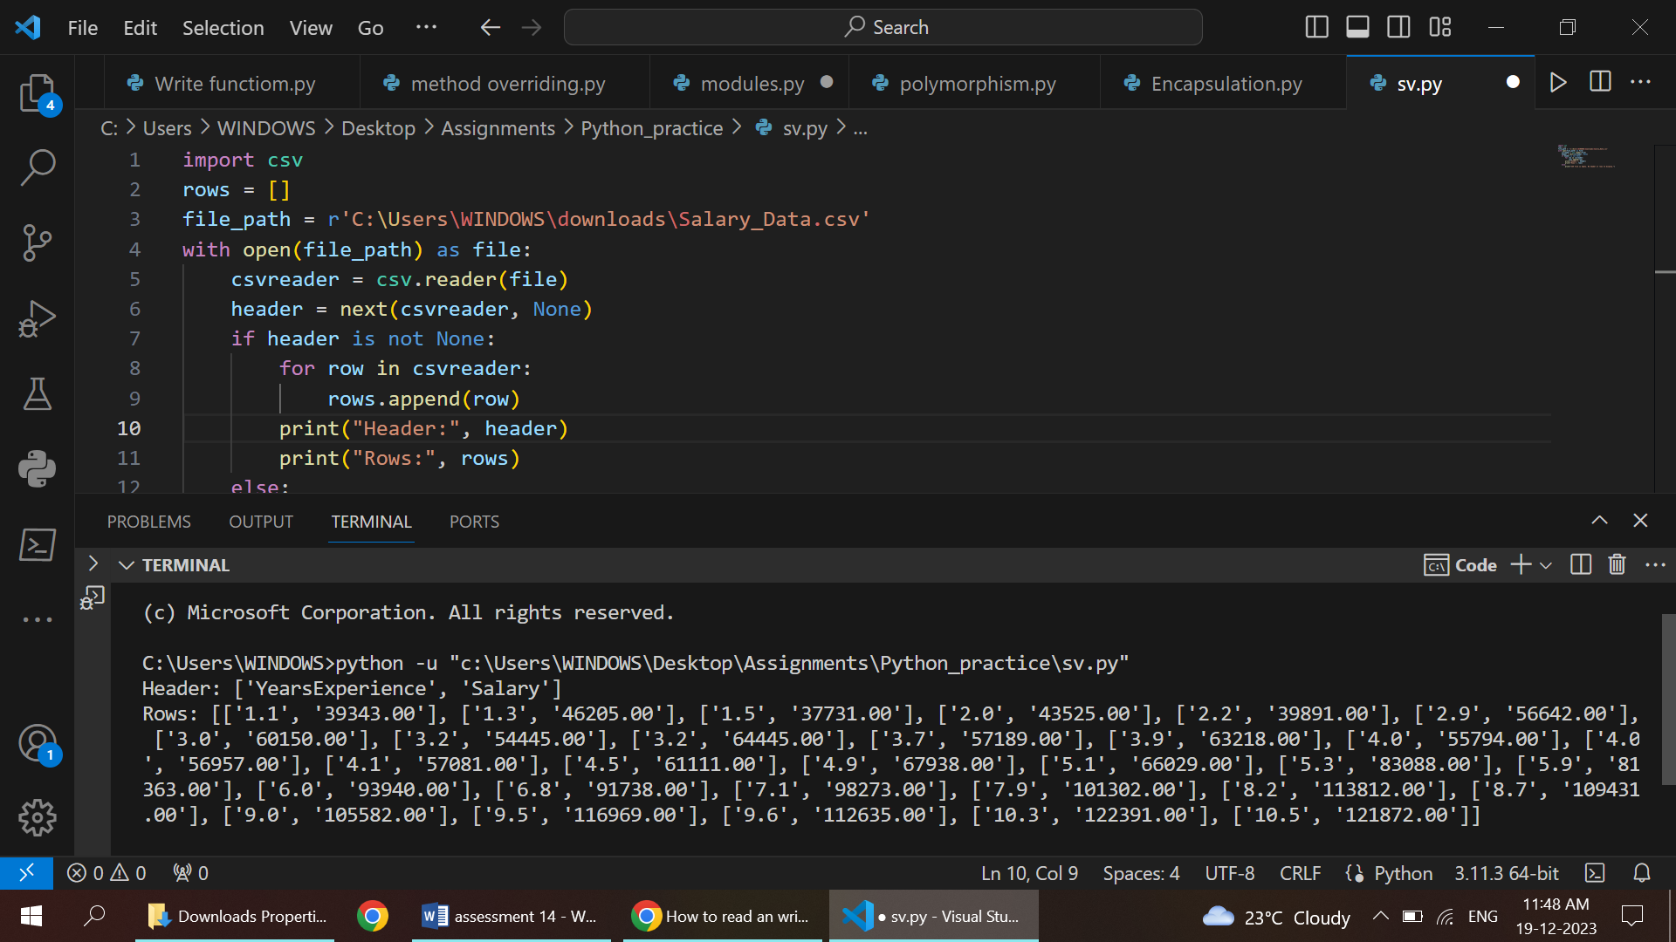

2. Read CSV Files in python Using .readlines()

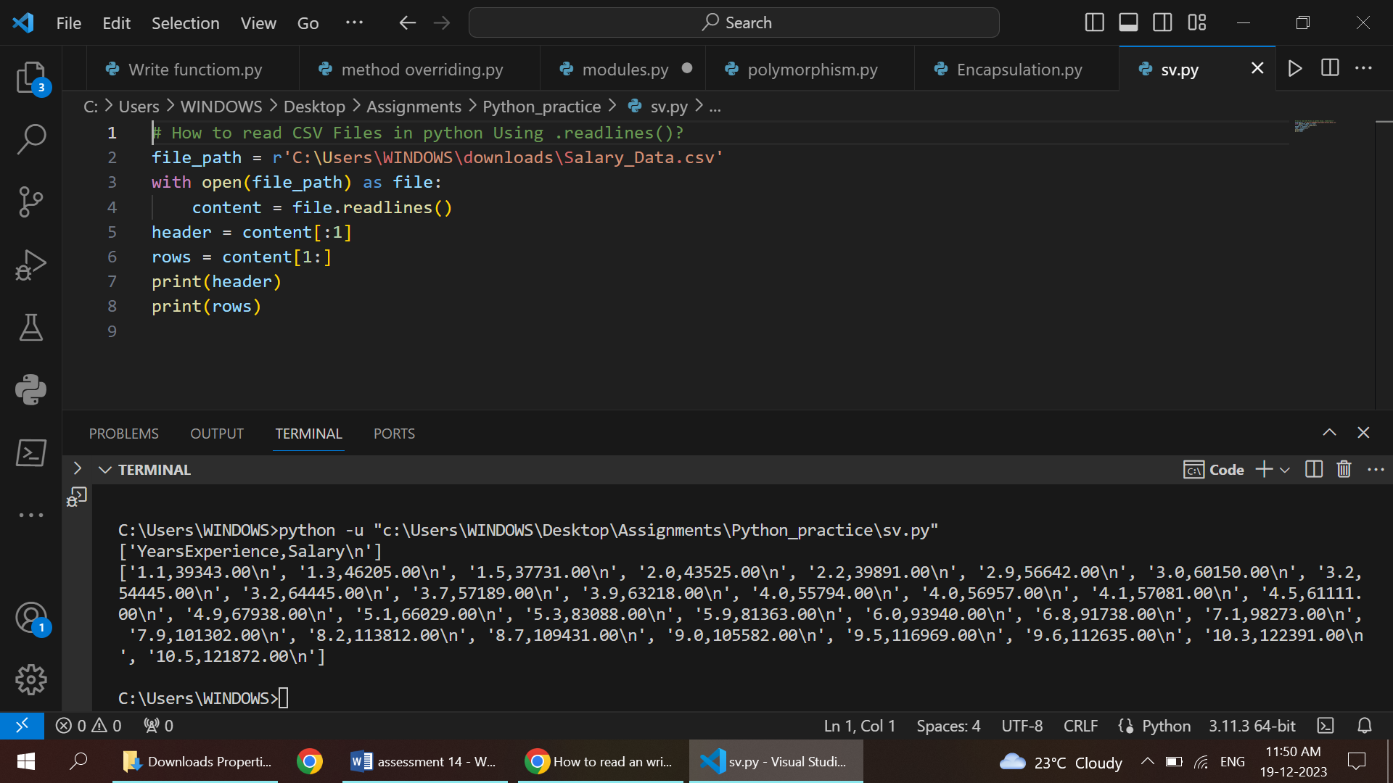

3.Pandas

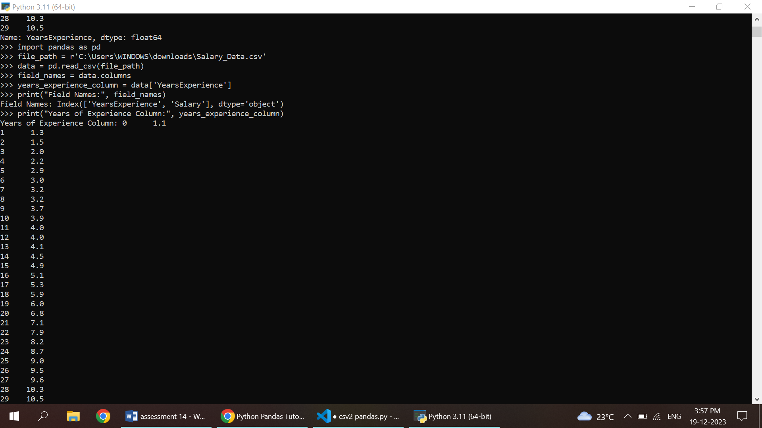

4.Read CSV file in python using csv.DictReader

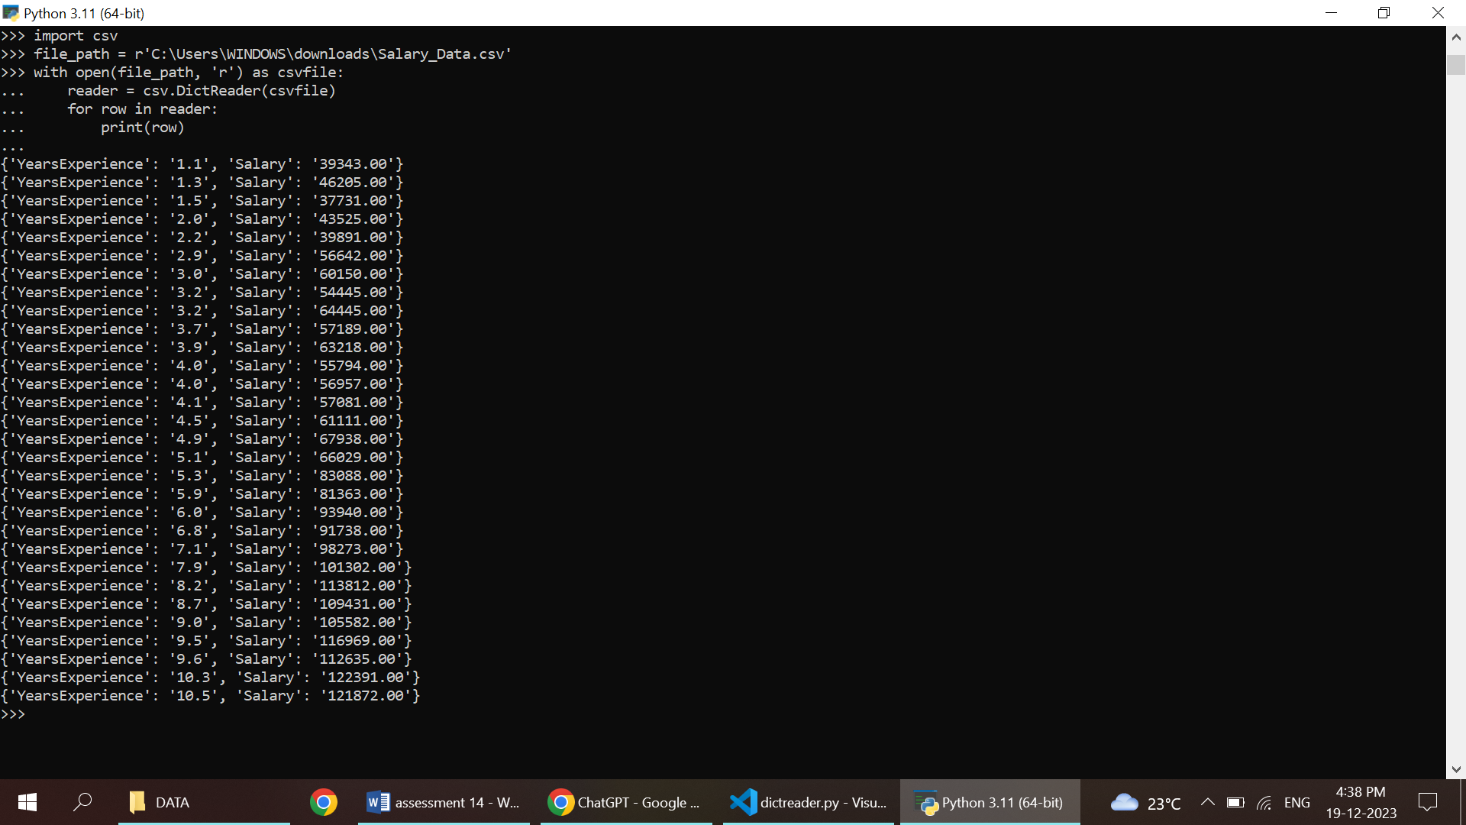

5. Write CSV file Using csv.writer

Write CSV File Using csv.DictWriter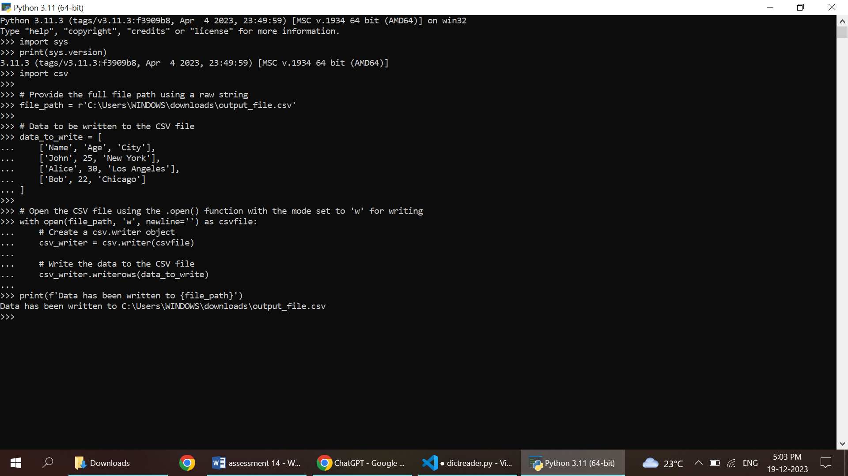

6. Write CSV File Using csv.DictWriter

